submitted TO: Muhammad Ali khan

OOP ASSIGNMENT 1

THEORY ASSIGNMENT

|  |  |
| --- | --- |
| **Name** | **Muhammad Abubakar Siddique** |
| **Registration No.** | **FA20-BSE-084** |
| **Section** | **B** |
|  |  |

**Qno1: Is Data Hiding and Encapsulation is always necessary in program?**

**Answer:** **No**, there is no always necessary of data hiding. Because when we design such software’s and databases where everything can be in hand of users. So, at that situation data hiding is not necessary.

**Data hiding** means keep the states of class private. Private keyword hides the state or data for other class. It cannot be accessed by the other class. If we try to access the private data, then we get this error.

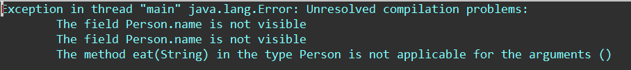

**Encapsulation** is necessary in program because encapsulation allows user to enter valid data using setter and getter methods. Doing encapsulation in program is a very good practice. Encapsulation makes the code flexible and improves the maintainability.

**For Example:**

package Practice;

import java.util.Scanner;

public class ExApp {

public static void main(String[] args) {

Scanner input = new Scanner(System.***in***);

Example ex = new Example();

System.***out***.print("Please enter name: ");

ex.setName(input.nextLine());

ex.getName();

}

}

package Practice;

public class Example {

String name;

public void setName(String name)

{

if(name.length()<20)

this.name = name;

else

System.***out***.println("Please enter valid name");

}

public void getName()

{

System.***out***.println("Name: " + name);

}

}

In this example user enter name if the length of name is greater than 20 then it prompts the message “Please enter valid name”. So, encapsulation prevents to enter invalid data.

**Qno2: Citizen class has two states first is cnic and second one is name of type int and String respectively. A setter of type void and a getter of int that sets and returns the name state. The object of this class is created in another class that holds main method. Explain the size which is reserved by both classes?**

**Answer:** There are Stack and heap in JVM which are used for memory allocation.

**Stack memory allocator stores local variables and the reference of objects on the other hand Heap memory allocator stores instance variables and the objects.**

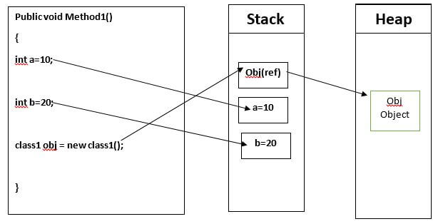

Basically object has minimum size of 16 bytes and its reference takes typically 4 bytes.

So, the object of Citizen which is created in another class i.e its object is

**Citizen person1 = new Citizen ();**

person1 is the reference of class Citizen which reserves 4 bytes in Stack.

And object which is created reserves 16 bytes in heap.

And setter and getter do not affect memory.

**Qno3: Why there is a need of multiple constructor and multiple methods of same name in a class? Explain with example.**

**Answer:** There is need of **multiple constructor** of same name in a class because it helps you to inialize objects by different ways.

There is need of **multiple methods** of same name in a class because it makes the code cleaner and efficient

 These constructors and methods can have any number of parameters and they are used in initializing instance variables and sets and gets the behaviors of these states respectively. Complier identify the these by the no. of parameters, order of parameters and type of parameters

**Using multiple constructors of same name in a class is called constructor overloading.**

**Using multiple methods of same name in a class is called method overloading.**

 For example, you have a Person and let name and age be Person attributes.

public class Person  
{  
    private String name;  
    private int age;  
      
    //At time of birth you don't have name  
    public Person()  
    {  
        name="";  
        age=0;  
    }  
      
    //if you don't want to reveal age   
    public Person(String name)  
    {  
       setDetail(name);

    }  
      
    //if you give all details  
    public Person(String name, int age)  
    {  
       setDetail(name,age);

    }  
      
    //method representing set details

public void setDetail(String name)  
   {  
       this.name = name;

  }

public void setDetail(String name,int age)  
    {  
       this.name = name;

this.age = age;

    }  
  
         
}

**Qno4: Pen class has four states**

* **color of type String**
* **ink of type String**
* **manufacturer of type String**
* **inkThickness of type double**

**how many setter and getters will be in the class and why? And which state can be private and Why?**

**Answer:** Class Pen consist four state, "color" type string, "ink" of type of string, "inkThickness" of type double and "manufacture" of type string.

So we need Four setter and four getters method to set and get a value because we want to enter valid data by the user. And we have to make three state private which is "color”,"ink" and” manufacture" because the pen manufacturer does not want to change the properties of pen by the user.

You can't make "inkthickness" as private it should be public because the thickness of pen can be changed by the user.